HSE Board Paper

For noting

Thursday 28 April

Sponsoring Director : Brian Gilroy

Presenting : Fran Thompson

In line with Irish government sector best practice and in consultation with the Department of Health and Children and the Department of Finance (CMOD), HSE have rewritten its ICT strategy. The strategy becomes the document against which all future ICT investment will be tested by the new HSE ICT steering group and by CMOD. It is not a detailed implementation plan but it will inform the content of the corporate and annual capital plans as will any funding constraints that may emerge. Below is a summary of the content of the strategy and the strategy itself is attached.

The board is asked to note the adoption of this strategy by HSE executive.

ICT Strategy – The Starting Point

ICT infrastructure and applications are substantially as they were when the HSE was formed in 2005. Whilst investments have been made to streamline some aspects of it, reduce costs and increase capacity in certain areas, in the main the solutions available today are still based upon the legacy ICT infrastructure and applications that was deployed during the time of the health boards. Even the email systems, while presenting users with a @hse.ie address are no more than a collection of the previously discrete health board email systems. Whilst this approach has served the health service reasonably well so far by providing continuity of service with minimal additional investment, fundamental deficiencies are now apparent and need to be addressed. The ICT Strategy will address those deficiencies.

The following graphic illustrates the complexity of delivering national ICT using legacy infrastructure and applications.

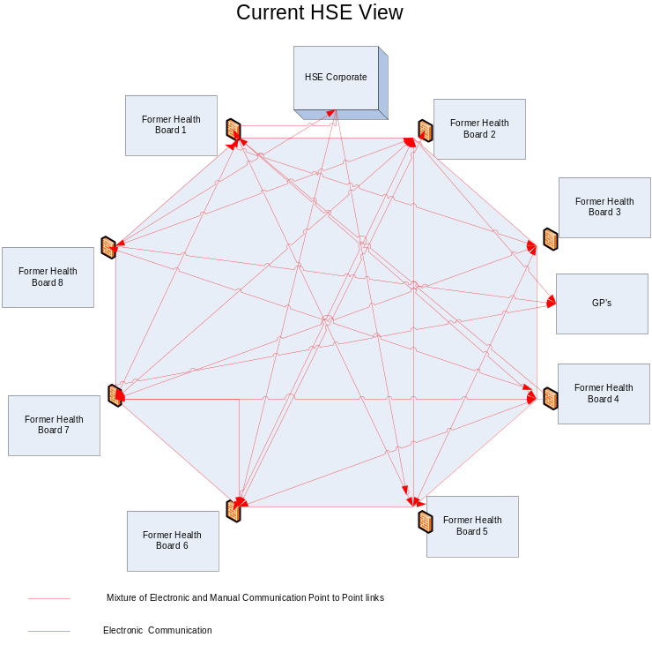

Each former health board had its own Wide Area Networks (WANs) that linked sites within the board, Local Area Networks (LANs) on each site, PC’s, Data Center (s)/ Computer Rooms, Single email system (Outlook or Lotus Notes), Internet Access, Common (and discrete) clinical and administrative applications, limited common diagnostic systems and decision support systems. Consequently, connecting former health boards together creates an extremely complex ICT infrastructure with the associated difficulties you would expect as health staff from one former board try to access systems, applications and data from other former health boards.

Without change, the HSE will find it increasingly difficult to manage the health service as a single entity and almost impossible to implement meaningful ICT solutions that support the patient journey and the integrated model of care. Provision of national visibility on metrics that are available e.g. performance management and financials, will continue to present a large administrative burden at a time when headcount needs to be reduced. To address these challenges, the ICT strategy focuses on key elements, some of which are illustrated in the following table.

Key Element | As Is | What is proposed ? | Detail  (of what is proposed) | Why Change ? | Cost & Timing OOM Estimates **
Rationalised ICT Technical Infrastructure | Legacy infrastructure that is (mainly) health board based. Firewalls and other components prevent access to systems, infrastructure and shared folders on other health board sites. Tactical connections provide some capability. | A single national ICT infrastructure built from existing components – with seamless access to systems and services irrespective of where they are hosted – for authorised users | 2 x National Data Centres  Single resilient National Health Network (NHN1 + NHN 2)  Single enterprise wide integrated infrastructure | One health system – one infrastructure – connecting all health providers – better collaboration - better security, data management & governance | 2013  €5m - €7m
Rationalised set of ICT Applications | There are currently in excess of 1000 legacy applications which are difficult to manage - and absorbs significant amount of ICT resources | To rationalise the existing set of legacy applications by retirement, upgrade or virtualisation | A reduced set of more easily maintained legacy applications | To reduce total cost of ownership by providing internal application support wherever possible | Ongoing  €5m - €10m
Core Hospital Systems | Myriad of ‘core’ systems with varying degree of deployment and little realistic potential to deliver national Summary Care Records. | Deployment of (5) Core Systems to all HSE funded hospitals | PAS – iSoft  Order Comms – iSoft  NIMIS – McKesson  LIMS  Medication Management | Underpins delivery of national Summary Care Record and Electronic Health Record.  Establish consistent core hospital systems that support real time performance data. | PAS & Order Comms  2015  €30m - €40m  NIMIS  2013  €40M  LIMS  2015  €30m - €35m  Medication Management 2017  €30m - €35m
Primary Care | High adoption of practice management systems in GP surgeries – but largely isolated from the rest of the health service.  Primary Care Teams have basic ICT infrastructure with few applications | Enhanced methods to electronically link primary care with the rest of the health service – secure email, electronic referrals etc.  Additional applications and infrastructure for Primary Care Teams | Secure e-mail Electronic referrals (new)Electronic discharge notes  Universal Healthlink coverage – with expanded functionality | Fundamental requirement in order to shift the paradigm of care from acute hospitals towards primary care and the community | 2015  €2m - €3m
Corporate Systems | Limited ERP footprint  HSE corporate visibility usually only possible by collating data from legacy health board systems | National solutions that provide consistent views with minimal administrative overhead | National Finance & Procurement System  Single ERP Solutions  Enterprise wide Performance Management Systems | To provide timely, consistent, reliable corporate data - with less administrative overhead | NFPS  2018  €25m - €30m  Other  2014  €1.0m
Clinical Care Systems | Systems and applications mainly driven by hospitals and now subject to external sanction. | To implement clinical care systems and applications as defined by the national clinical care programmes | Best of Breed decision support tools - with standard interfaces to 'Core' Hospital Systems | To bring consistency to the applications deployed in support of each clinical care programme. | Requirements and costs to be defined
Pre Hospital Emergency Services (ambulance service) | ICT applications and infrastructure designed for legacy (health board based) ambulance service | Applications and infrastructure suitable for reconfigured ambulance service | 2 x Regional Control Centers  1 x National Digital Radio System  1 x Integrated Command & Control System  Supporting Applications | Necessary pre requisite for complete reconfiguration of the ambulance service | 2011  €2m - €3m  2011  €3.8m  2011  €3m  2012  €3.3m
Child Care | Legacy health board based child care information systems. No national view and varying degrees of functionality by area. Different applications and supporting processes. | A single National Child Care Information System | National standard processes supported by a national child care information system | To provide timely, consistent and reliable data.  To provide national visibility - subject to authorisation.  To avoid potential issues arising as children move/ are moved between former health board areas | 2016  €3.5m
Public Health | Computerised Infectious Disease Register(CIDR), Health Board based Immunisation Systems, Health Atlas | Implementation of additional national systems – with enhancements to existing ones | 1 x National Immunisation System  1 x National environmental Health System  Upgraded CIDR  Significant investment in Health Intelligence System/s | To enable the transition from local to management of key public health functions | 2014  €3 - €3.5

** OOM = Order of Magnitude timing and costs only – in some cases prior to completion of detailed analysis and Business Case.

The list is not exhaustive and excludes key areas such as Quality & Risk, Older People, Cancer Control, Mental Health etc.., details of which can be found in the ICT Strategy document itself.

